Learning to Sail
CLASS #1
INTRO, CLOTHING, AND BOAT SAFETY

I. INTRODUCTION TO GEORGIA TECH SAILING CLUB

- Welcome to the Georgia Tech Sailing Club!
- Meetings Thursdays at 7:30 p.m. - CRC
- Sailing most weekends, barbecues, campout, Florida trip, racing

http://www.gtsailing.org

terMINOLOGY

True Wind
Apparent Wind
Puff
Lull
Windward
Leeward
Luff (verb)
Heeling
Hiking Out
Port
Starboard
_____________________________________________________________________________________________________________________________________________________________________________________________________________________________________________________________________________________________________________________________________________________________________________________________________________________________________________________________________________________________________________________________________________________________________________________________________________________________

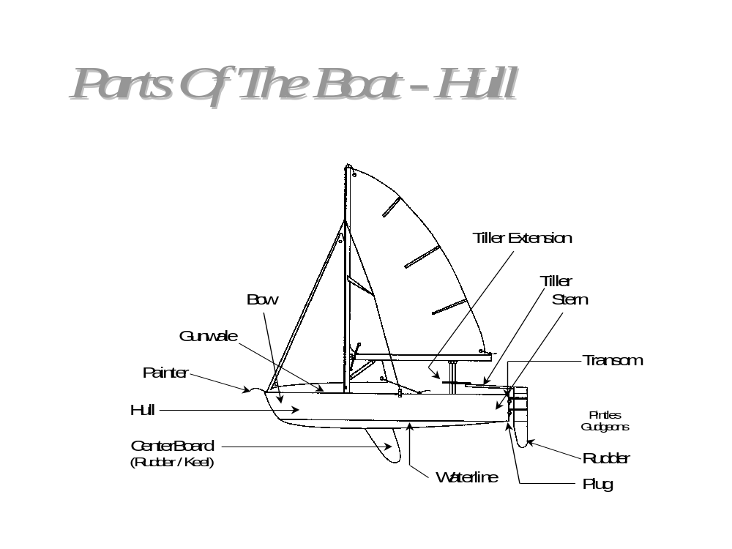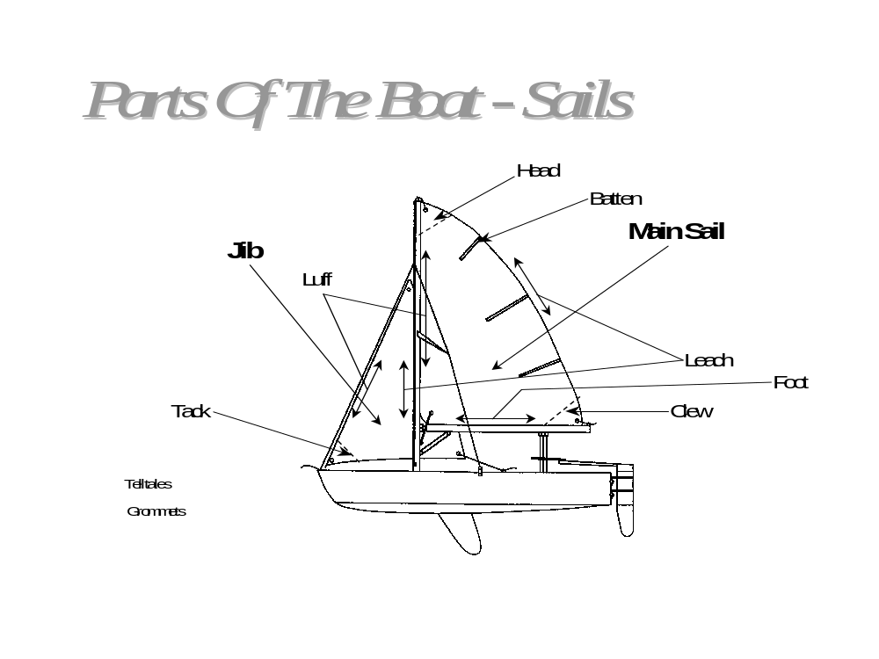
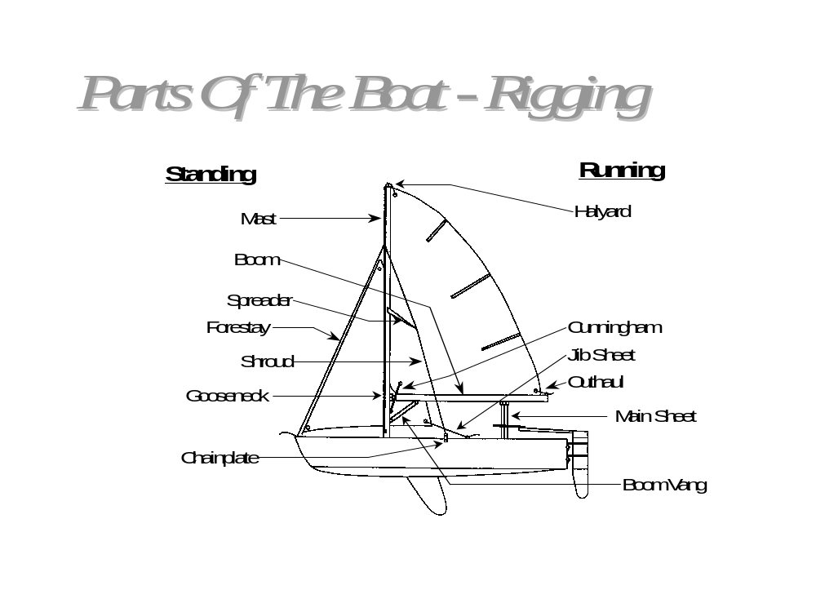

ii. clothes and equipment
- Layer, layer, layer!
- PFD’s on board the boat, one per person - MANDATORY
- Sunscreen, sunglasses, hat, sailing gloves, etc.
- Drinking water, Gatorade, food
- Bring a complete extra set of clothes, you will get wet!
- ALWAYS sail safely and cautiously

